IN Critical Threshold Crossed alarm LLD v2.0

Description
This doc describes the updates to be made in the IN rules files for the Critical Threshold Crossed alarms generated by IN nodes.

HLD:
Multiple directories and files are created on IN at runtime. When any of these directories reach threshold an alarm is sent. When these alarms are received a TT should be raised with the classification of QOS alarm in the TT after 5 minutes.

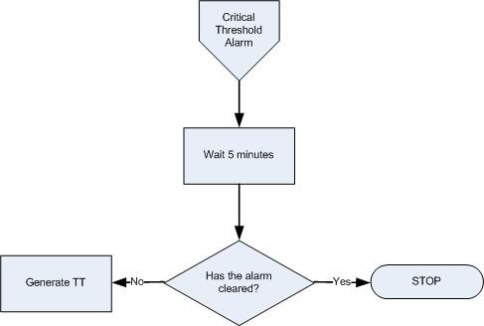

Critical Threshold Crossed alarm Handling Flow Chart

Pre-requisite
- Map added into TSRM between EventId “NET_IN_CTC_001” and classification “QOS ALARM”
- The TTHibernate field was added to the ObjectServer schema
- ML_RaiseTT trigger was added in the ObjectServer

Event Filter:
No. | Alarm description | Domain | Field | Value | EventId
1 | IN Critical Threshold Crossed | IN | Summary | RtpAudMgr01:Running out of file system or database space on /TspAccBackup: 10 percent available  Matching condition:  regmatch(@Summary, ".*Running out of file system or database space on .* percent available") | NET_IN_CTC_001
2 | IN Critical Threshold Crossed | IN | Summary | RtpAudMgr01:Running out of file system or database space on Global TspFt: 7 percent available  Matching condition:  regmatch(@Summary, ".*Running out of file system or database space on .* percent available") | NET_IN_CTC_001
3 | IN Critical Threshold Crossed | IN | Summary | RtpAudMgr01:Running out of file system or database space on /dump: 10 percent available,  Matching condition:  regmatch(@Summary, ".*Running out of file system or database space on .* percent available") | NET_IN_CTC_001
4 | IN Critical Threshold Crossed | IN | Summary | RtpAudMgr01:File group oracleArchiveLog (path /export/home/oracle/dev/archivelog) too large, 55306 MB now,  Matching condition:  regmatch(@Summary, ".*File group .* too large") | NET_IN_CTC_001
5 | IN Critical Threshold Crossed | IN | Summary | OEM:in2ce1:Warning on Host in2ce1: -, /dev/vd/vdisk800 (-), File System usage (91) has exceeded the Warning level (90),  Matching condition:  regmatch(@Summary, ".* File System usage .* has exceeded the Warning level") | NET_IN_CTC_001
6 | IN Critical Threshold Crossed | IN | Summary | OEM:in1ce2:NOTICE: alloc: /global/TspFt: file system full,  Matching condition:  regmatch(@Summary, "OEM.* file system full") | NET_IN_CTC_001

Logic:

IN Critical Threshold Crossed alarm received
- Assign EventID, Domain and set TTHibernate=300 (seconds) for relevant network alarms as defined in event filter section.

If not cleared after TTHibernate time, raise a TT for the alarm.
- The ML_RaiseTT trigger checks for TTHibernate>0, Severity>0 and CurrentTime-FirstOccurrence>=TTHibernate and sets the alarm for ticketing (@LogTicket=1).

Resolution of events
EventId | Resolution mechanism
NET_IN_CTC_001 | - Clearance of the network event is managed by its resolution event.  - Clearance of the network event is managed by the TSRM gateway when the related ticket is RESOLVED.

